**Delivering real business value of your Enterprise Architecture (EA) using “Value Streams”- Key points**

1. Have a clear vision for the Org -- Purpose & where they are headed

2. Strategy communication & implementation is a traditional approach

-- A strategy in effect results in little pieces that are picked up in different parts of the Org which is broken down into tasks, project executions, program increments and assigned to individuals at precise action oriented levels.

-- Ultimate alignment to the strategy may be lost

3. An EA practice aims at aligning the enterprise execution (operating model) to the company strategy. "Continuously align the strategy & operations"

4. EA & modern agile software development groups need to work together towards a common Org goal i.e Agile teams should not look upon EA as work stoppers & EA should not impose constraints on software dev teams. Instead, both should work collaboratively towards achieving the Org's goals. EA teams should help dev teams to achieve their goals.

5. EA teams should establish rules, boundaries, patterns, best practices, guardrails, success elements that will help & guide teams to achieve their goals. The greatest success will come from cooperation between the EA practice & s/w team members.

6. "Value Streams" enables to works across different architecture teams EA, Sol Architect, System architect. It helps take the strategic vision that we need to achieve, break it down into customer centric actionable approach, articulate elements around business capabilities and put it into an actual roadmap for transformation.

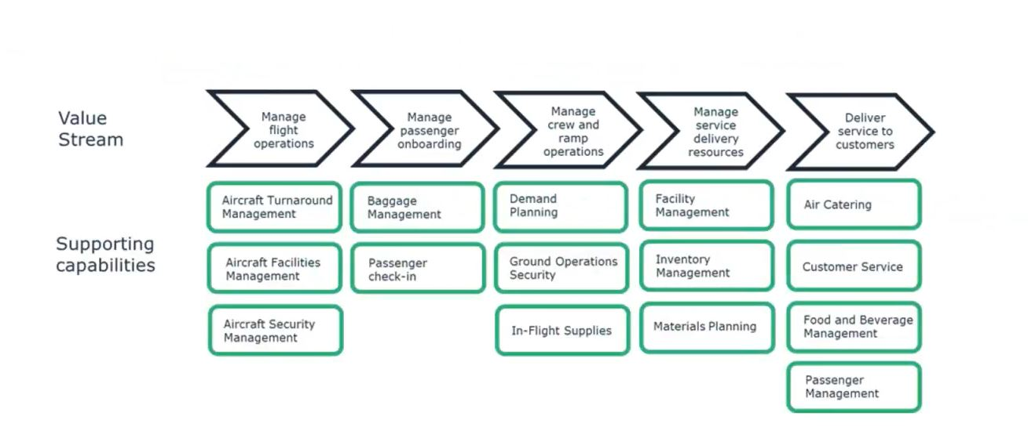

7. "Value Streams" business processes focuses on customer centricity and different elements that add specific value to customers. Below the value stages (business process) of the value streams will be business capabilities that are needed to fulfill the vision of the value stream

8. Now we look into the Org strategy & identify what changes in the business capabilities need to brought about to fulfill the strategy of the Org

9. Value Stream Maps (VSM) uses a 4 step approach to develop & optimize services

-- Identify customer

-- Identify steps(stages) in the value stream that will provide concrete value to that customer

-- Find business capabilities underpinning these value stream stages

-- Use the value streams to transform & optimize the service & operating models

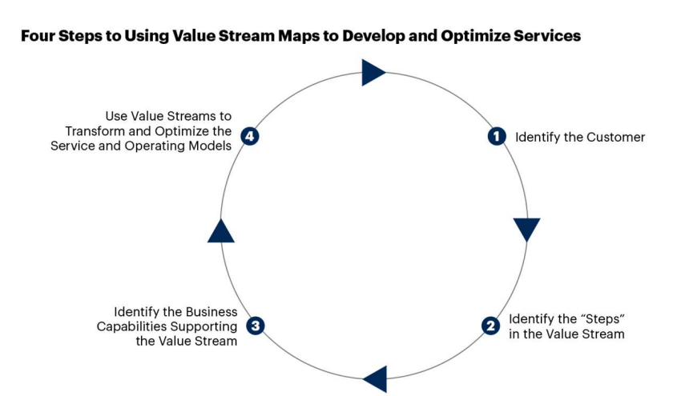

10. VSM's are essential to building, transforming & optimizing an Org's technology enabled business models.

11. VSM's provide insight & lens into how underlying applications, information & technology support the end-end value stream activities

12. Once built, a value stream can be used at the enterprise level (top down) & product level (bottom up) to identify, analyze & determine the applications, information & tehnologies required in digital platforms to enable & drive the Org's future state operating model and its supporting business process.

-- Map applications to value stream activities via the business processes

-- Determine whether application functionality supports the value stream

-- Model information flow along the business process

-- Identify opportunities for better application integration and improved functionality

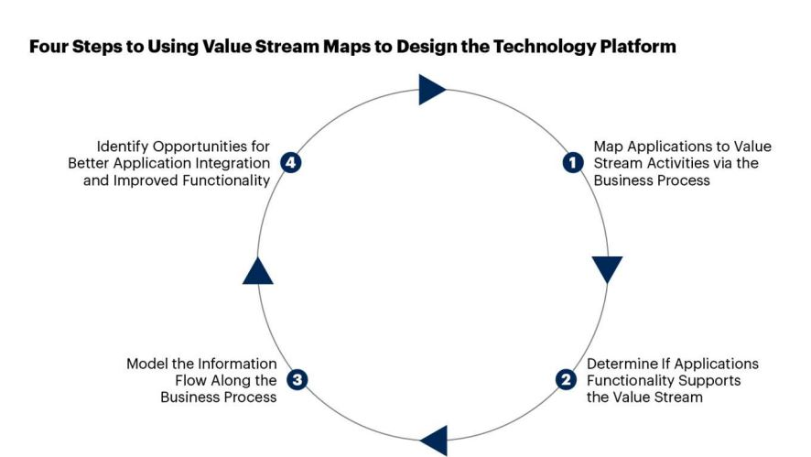

10. Value streams socialize knowledge across functional silos of how business capabilities interact to drive value to the customer

11. Outcomes from capabilities

-- Metrics can be attached to capabilities that can measure whether the capability is underperforming wrt Org strategy

-- To fulfill the Org strategy, what changes in People, Process & Technology need to brought about to improve the metrics & enhance the capability

-- By doing this, strategic value of software that really demonstrates customer value. This can be a differentiator between One org with another.

12. Role of EA is to enable, accelerate & facilitate using

-- Standards, principles, patterns, controls. Bring in commonality eg security of common services

-- Provide a path to developers

13. AN EA in the modern Agile world may just use enough Architecture using EA frameworks like TOGAF. Instead of following an entire ADM lifecycle, minimal architecture required for Agile teams to start implementation is the way to proceed

**Value Streams Implementation Approach**

1. Use EA framework tools like TOGAF content framework to develop the Architectural Building Blocks (ABB's). The major ABB's are described below

-- A motivation model built using the content framework's meta-model elements. These Architectural Views will represent the Architecture Vision based on the Org's strategy. Measurable business outcomes for Org goals & its corresponding course of action resulting in creation of new business capabilities / updation of existing business capabilities can be depicted.

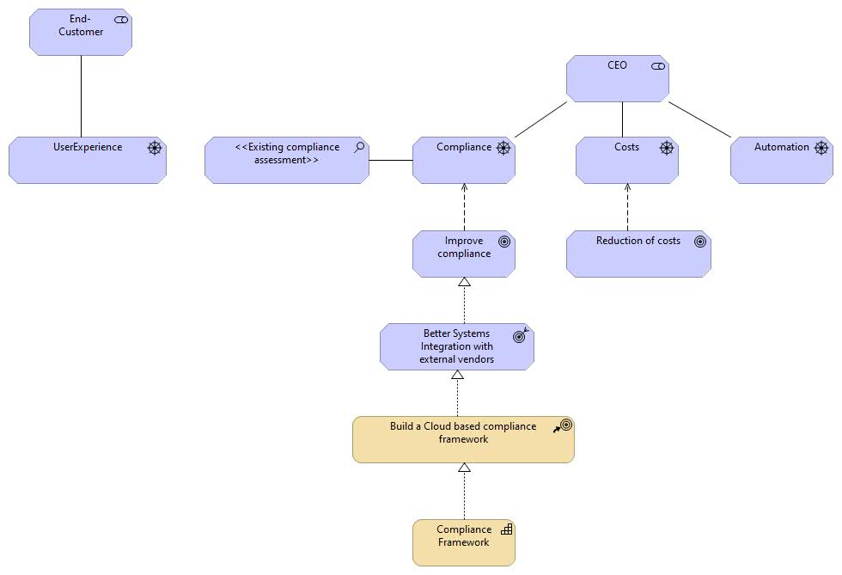

-- Represent major business processes as value streams and align corresponding business capabilities with those processes.

-- Develop corresponding Business Architecture, Application Architecture, Data Architecture, Technology Architecture for the identified value streams & business capabilities when required.

2. Build an Intentional Architecture (Solutions/IT architecture) for the identified ABB's. The IT architecture should be able to fulfill the strategic vision of the organization which has been identified using the Value Streams approach. All IT decisions, technology stack selection, costs should be justified to provide value for all business outcomes

3. During execution of Agile sprints, EA team should collaboratively work with Software architects, designers, dev teams & help them in achieving the Org goals and govern the dev efforts to ensure that the deployment of software artifacts are aligned to the Org strategy and they are able to fulfill the measurable business outcomes.

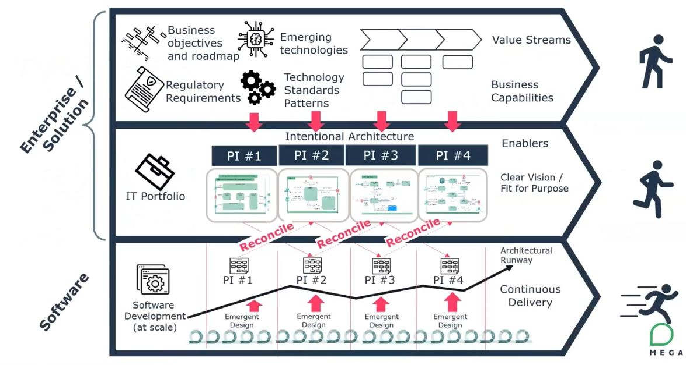

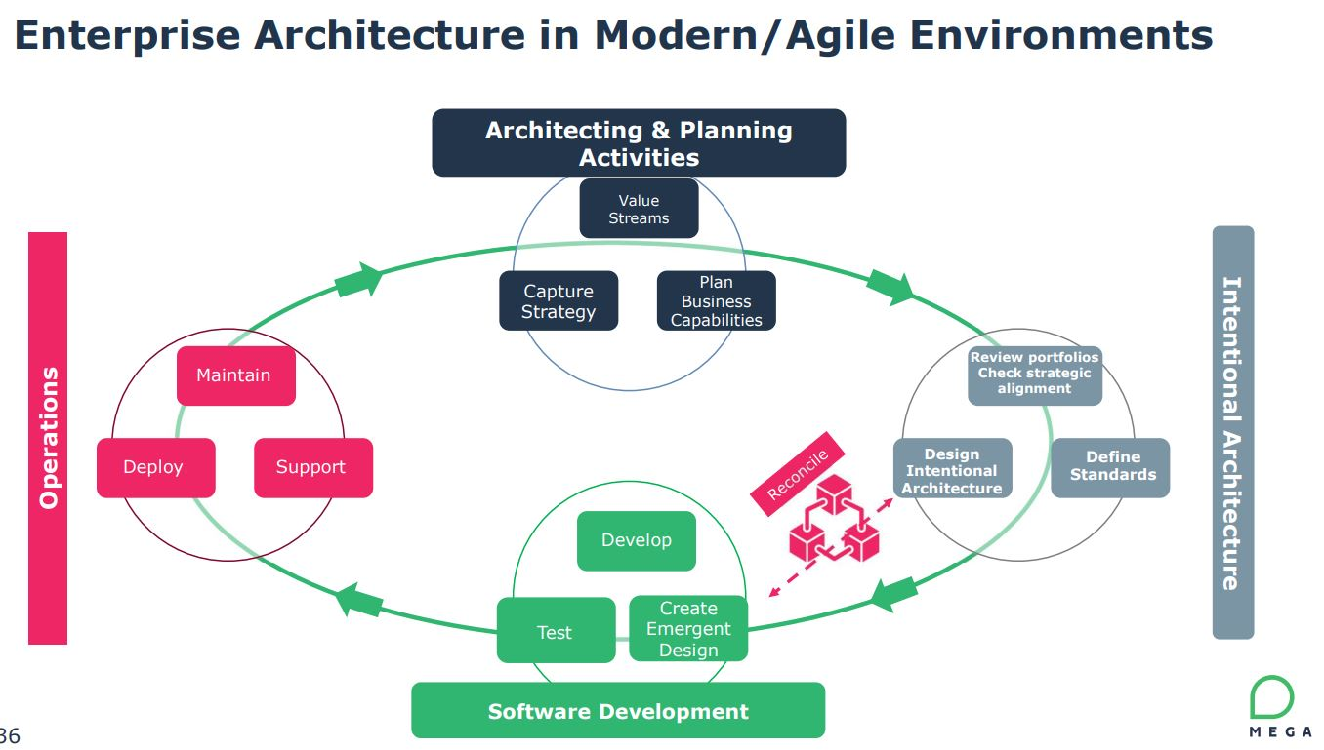

**Data Principles**

* Data is an asset

Data is a valuable corporate resource; it has real, measurable value. In simple terms, the purpose of data is to aid decision-making. Accurate, timely data is critical to accurate, timely decisions. Most corporate assets are carefully managed, and data is no exception. Data is the foundation of our decisionmaking, so we must also carefully manage data to ensure that we know where it is, can rely upon its accuracy, and can obtain it when and where we need it.

* Data is shared

Timely access to accurate data is essential to improving the quality and efficiency of enterprise decision-making. It is less costly to maintain timely, accurate data in a single application, and then share it, than it is to maintain duplicative data in multiple applications. The enterprise holds a wealth of data, but it is stored in hundreds of incompatible stovepipe databases. The speed of data collection, creation, transfer, and assimilation is driven by the ability of the organization to efficiently share these islands of data across the organization. Shared data will result in improved decisions since we will rely on few er (ultimately one virtual) sources of more accurate and timely managed data for all of our decision-making. Electronically shared data will result in increased efficiency when existing data entities can be used, without re-keying, to create new entities.

* Data is accessible

Wide access to data leads to efficiency and effectiveness in decision-making, and affords a timely response to information requests and service delivery. Using information must be considered from an enterprise perspective to allow access by a wide variety of users. Staff time is saved and consistency of data is improved

* Data trustee

One of the benefits of an architected environment is the ability to share data (e.g., text, video, sound, etc.) across the enterprise. As the degree of data sharing grows and business units rely upon common information, it becomes essential that only the data trustee makes decisions about the content of data. Since data can lose its integrity when it is entered multiple times, the data trustee will have sole responsibility for data entry which eliminates redundant human effort and data storage resources

* Common vocabulary & data definitions

The data that will be used in the development of applications must have a common definition throughout the Headquarters to enable sharing of data. A common vocabulary will facilitate communications and enable dialog to be effective. In addition, it is required to interface systems and exchange data.

* Data Security

Data is protected from unauthorized use and disclosure. In addition to the traditional aspects of national security classification, this includes, but is not limited to, protection of pre-decisional, sensitive, source selection-sensitive, and proprietary information.

**Current stakeholder concerns**

|  |  |  |  |  |
| --- | --- | --- | --- | --- |
| **Concern** | **Description** | **Data Principle violated** | **Solution** | **End Goal** |
| Duplication of Accounts & Contacts | Currently Accounts & Contacts have duplications in SFDC leading to redundant data and making it difficult to select the corresponding entity for assignment | Data is an asset | Manual Merge using a Tool.  Run jobs using scenarios / filters to identify duplicates.  Create rules in SF to avoid creation of duplicate records. | The solution will ensure that the system does not contain obsolete or redundant data. This will help to easily identify entities & also save storage space. |

https://youtu.be/JuEE0MySHY0